AI ASSISTED CODING

# NAME : N.KEERTHI REDDY

# HALL.NO : 2403A52376

# BATCH : AI 14

# TASK-1

def add(a,b):

    return a+b

print(add(2,3))

# OUTPUT :

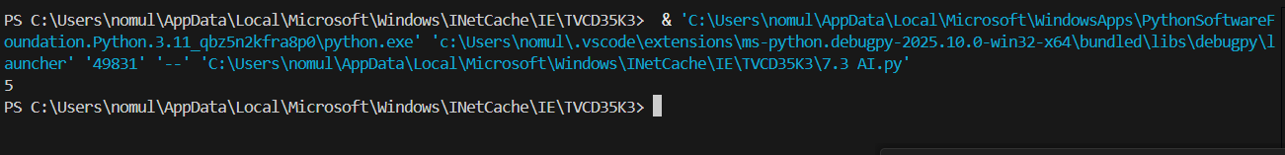

**EXPLANATION :**

## This code defines a function called count_down that takes one argument n. Inside the function, a while loop is used to print numbers starting from n down to 0. The loop continues as long as n is greater than or equal to 0. In each iteration, the current value of n is printed, and then n is decreased by 1.

TASK -2

def infinite_loop_example():

n = 5

while n >= 0:

print(n)

n -= 1 # Decrement n to avoid infinite loop

infinite_loop_example()

# OUTPUT :

# EXPLANATION :

The code defines a function called infinite_loop_example. Inside this function, a variable n is initialized to 5. A while loop is used to print the value of n as long as n is greater than or equal to 0. The line n -= 1 inside the loop decrements the value of n by 1 in each iteration. This ensures that the loop will eventually terminate when n becomes less than 0. Finally, the function is called to execute the code.

0 / 2000

Gemini can make mistakes so double-check it and use code with caution. [Learn more](http://g.co/legal/generative-code)

*values: object, Prints the values to a stream, or to sys.stdout by default. sep &nbsp;&nbsp;string inserted between values, default a space. end &nbsp;&nbsp;string appended after the last value, default a newline. file &nbsp;&nbsp;a file-like object (stream); defaults to the current sys.stdout. flush &nbsp;&nbsp;whether to forcibly flush the stream., hint

TASK – 3

ERROR CODE :

def divide(a, b):

return a / b

print(divide(10, 0))

EXPLANATION FOR ERROR :

• If b is 0, Python will raise a ZeroDivisionError, and the program will crash.

• We need to catch the error and handle it gracefully using a try-except block.

# FIXED CODE :

def divide(a, b):

try:

return a / b

except ZeroDivisionError:

return "Error: Cannot divide by zero"

print(divide(10, 0))

# OUTPUT :

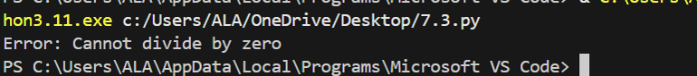

# EXPLANATION FOR FIXED CODE :

• try: block attempts the division.

• If b is zero, the code jumps to the except ZeroDivisionError: block.

• Instead of crashing, it returns a friendly error message.

TASK – 4

# 